**Activity 29**

**NAME : Shalini devi.M COURSE : Mobile Computing**

**Reg No : 192421351 COURSE CODE: ITA0302**

Figma, showcasing the peer-to- peer interactions in real-time.

**Aim:**

Wireframes for a collaborative mobile app,showcasing the peer-to-peer interactions in real-

time using figma

**Procedure:**

1. Open Figma
2. Create a new file
3. Select the Frames
4. Design Visual Elements
5. Make it Interactive
6. Add icons on the Frame
7. Incorporate Multimedia
8. Storyboard Animation
9. Review and edit the Prototype
10. Save and Share

**Design:**

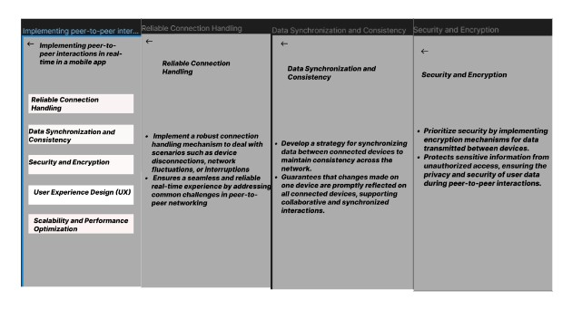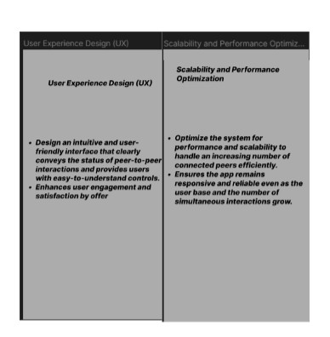

**Prototype:**

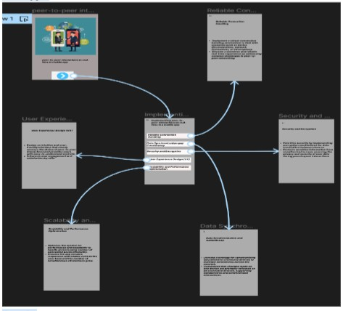

**Result:**

HenceWireframes for a collaborative mobile app,showcasing the peer-to-peer interactions in

real-time using figma have been created successfully